
The Journey of Henry “Box” Brown
SOCIAL STUDIES LESSON PLANS
Introduction
On March 23, 1849, Henry Brown began one of the most dramatic escapes from slavery in American history. A white friend named Samuel A. Smith helped Brown hide himself in a box that was shipped from Richmond to Philadelphia. In just over 24 hours with hardly any food and water and partly upside-down, Henry Brown traveled by wagon, train, and boat until his box was opened by leaders of the Underground Railroad in Philadelphia. James Miller McKim (Dickinson Class of 1828) and William Still, the son of former slaves, helped free Henry “Box” Brown and set him on a course to become one of antebellum America’s most famous escaped slaves. His own story has been told in two versions (http://docsouth.unc.edu/neh/boxbrown/menu.html and http://docsouth.unc.edu/neh/brownbox/menu.html) and by William Still (http://deila.dickinson.edu/theirownwords/title/0088.htm) and in a fascinating new biography by historian Jeffrey Ruggles called The Unboxing of Henry Brown (http://www.shop-vahistorical.org/boxbrown.html). Now, the story is also available at this website as a Google Earth tour complete with historical map overlays, supporting text, images and even an interactive timeline.

Elementary School
Packing for a Trip

Middle School
Building the Box
Cooperative Storytelling

High School
Six Degrees of Henry “Box” Brown

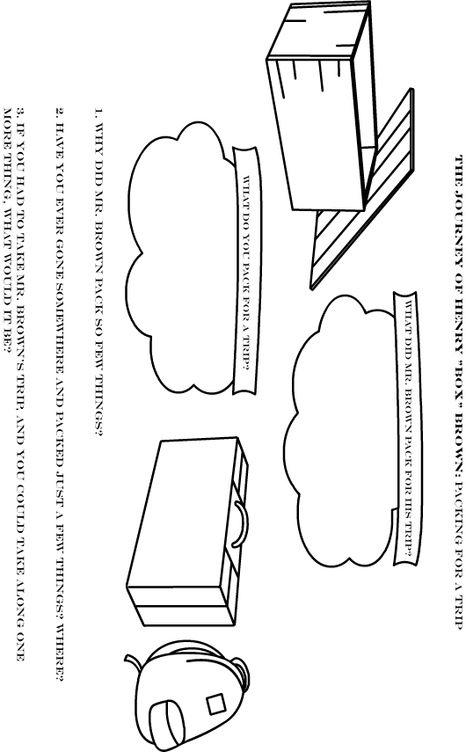
The Journey of Henry “Box” Brown
Building the box

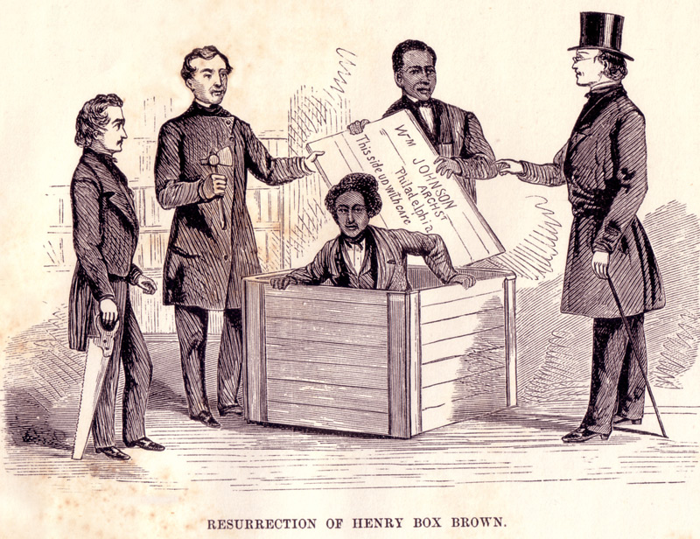
One of the more fascinating parts of the story of Henry “Box” Brown is how Brown spent over 24 hours in a box during his trip. How big was the box? Would you be comfortable in it? Let’s find out…

Read the following excerpts from Brown’s story and find the dimensions:

“Ordinary modes of travel he concluded might prove disastrous to his hopes; he, therefore, hit upon a new invention altogether, which was to have himself boxed up and forwarded to Philadelphia direct by express. The size of the box and how it was to be made to fit him most comfortably, was of his own ordering. Two feet eight inches deep, two feet wide, and three feet long were the exact dimensions of the box, lined with baize. His resources with regard to food and water consisted of the following: One bladder of water and a few small biscuits. His mechanical implement to meet the death-struggle for fresh air, all told, was one large gimlet."

William Still, The Underground Railroad (Philadelphia: Porter & Coates, 1872), 81.

height:_________in. width :_________in. length:_________in.

Try building the box. You can use cardboard or posterboard, or you can tilt over some desks and get the right length and width.
You are not the first person to build the box. It has been done many times, here are a few examples:

What did Brown take with him in the box?

The Journey of Henry “Box” Brown
Cooperative storytelling

Use your knowledge of the story of Henry “Box” Brown to complete the following, but do not answer any questions on your sheet. Have other students in the class answer the questions on your sheet. You may not use any class member more than once. To keep track of that, have them write their initials on the line below the answer area for each question. Show your sheet to your teacher when you’re finished.

1. In what city did Henry “Box” Brown begin his journey?  ________ | 2. Henry Brown traveled using many forms of transportation. Can you name them all?  a.  ________  b.  ________  c.  ________ | 3. Why did Henry Brown have a false address on his box?  ________
7. Roughly how big was Henry Brown’s box?  ________ |  | 11. In what city did Henry “Box” Brown end his journey?  ________
4. Henry Brown traveled through what state, without ever leaving the box?  ________ | 5. Why didn’t Henry Brown get out of the box as soon as he reached Pennsylvania?  ________ | 6. What was a problem Henry Brown had to face while in the box?  ________
10. Name a few friends of Henry Brown who helped him on his journey:  a.  ________  b.  ________ |  | 9. If someone mailed you from Virginia to Pennsylvania today, what would be different about your journey?  ________
8. What did Henry Brown have with him in the box?

________
The Journey of Henry “Box” Brown
six degrees of Henry “box” brown

It has been said that all humans on Earth are “six degrees” from each other. So, you have someone you know who knows someone else, etc., about six times, until you are linked to any other person on Earth. Whether it is true or not, people have been toying with the idea in many interesting ways.
For example, a few years ago, it was theorized that the movie actor Kevin Bacon was within six degrees of any other major movie actor through the movies in which he had a role. So, every movie actor was figured to be “six degrees from Kevin Bacon.”
This is an interesting theory for historians, who are very used to trying to make connections between historical figures.
Using the Henry “Box” Brown tour, and the other resources below, draw a web that links the following people together. Let’s say that a valid connection means actual contact with the person through meeting them, being related to them, writing to them, or working with them. Between each set of persons, be sure to describe the exact connection.

Henry “Box” Brown
William Still
Harriet Tubman
Frederick Douglass
John Brown
Dred Scott

Resources:

http://housedivided.dickinson.edu/blog/
http://housedivided.dickinson.edu/ugrr/
http://deila.dickinson.edu/theirownwords/browse.html

The Journey of Henry “Box” Brown
Suggested answers for “cooperative storytelling”

1. Richmond, VA

2.
a. wagon
b. train
c. barge/steamboat

3. To hide his real destination in Philadelphia.

4. Maryland

5. He should not have been removed until he reached the Vigilance Committee Office, and was behind closed doors and in the presence of friends.

6. Being turned upside down, being quiet

7. Two feet six inches deep, two feet wide, three feet long

8. Three biscuits, a water bladder, and a gimlet (used for making holes in wood)

9. Answers will vary- you would probably ride in a truck or maybe an airplane, you would probably arrive faster, you would probably be discovered when they scan the box.

10. Samuel Smith, James Smith, Dan, E.M. Davis, Mr. McKim, Lucretia and James Mott

11. Philadelphia

